**Data Transfer from Azure Blob Container to AWS S3 Bucket using Rclone**

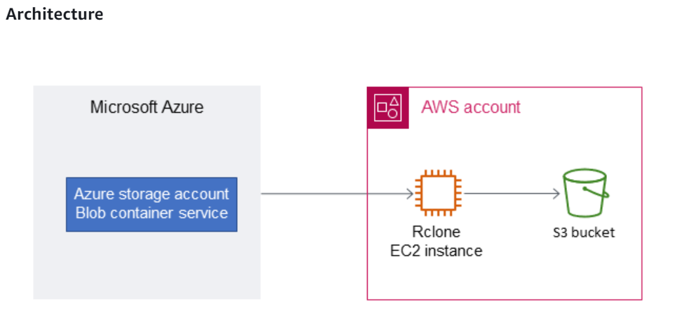  
  
Steps

1. Create AZURE Free Tier Account

* Create a Storage account
* Created a Blob container and uploaded sample data to test the migration process

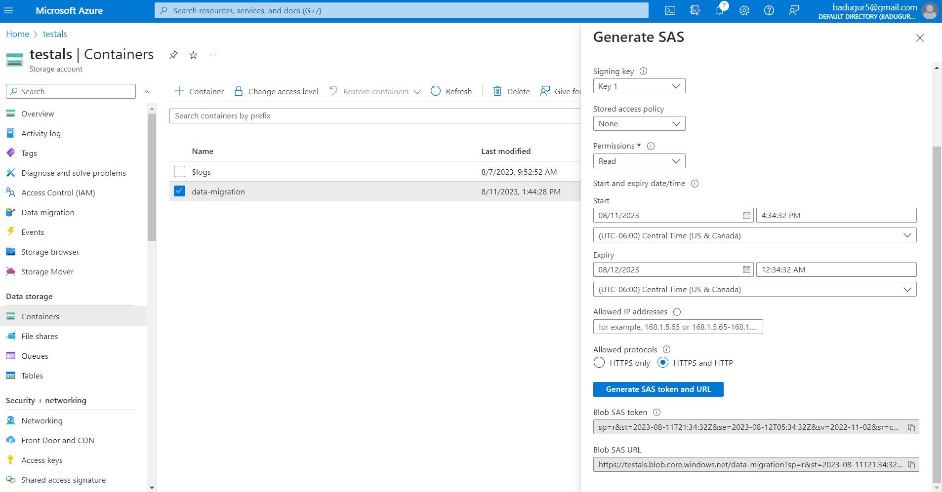

2. Create AWS Free Tier Account

* Create an IAM role to generate Acces_Key_ID & Secret_Access_key  
  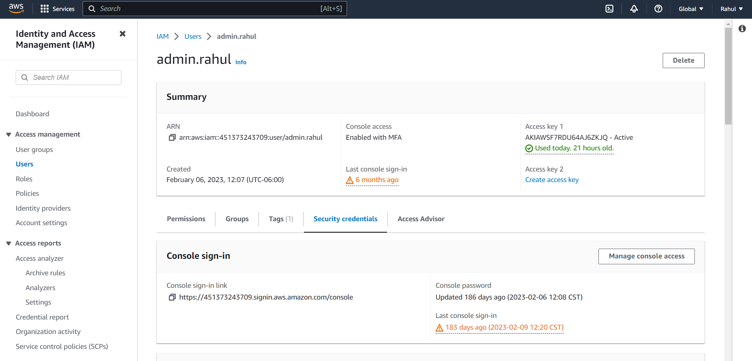
* Create an S3 Bucket with some test data & uploaded in the bucket  
    
  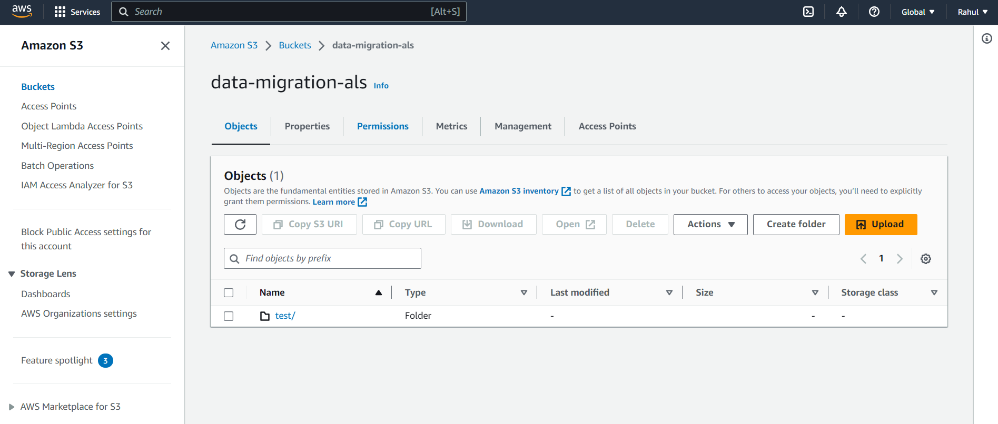
* Launch an EC2 Ubuntu Instance  
    
  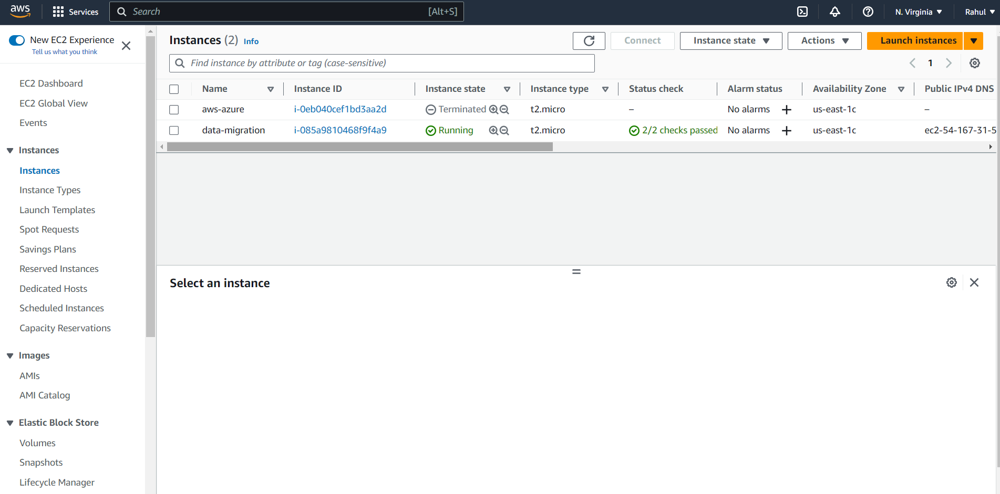
  + Install & setup AWS CLI v2 & configure to get aws cli access  
      
    Commands:   
    sudo apt install unzip  
    curl "https://awscli.amazonaws.com/awscli-exe-linux-x86_64.zip" -o "awscliv2.zip"  
    unzip awscliv2.zip  
    sudo ./aws/install  
      
    aws configure  
    Enter Access_key_id  
    Enter Secret_Access_key
  + Install & setup Azcopy in the instance  
      
    curl -o azcopy.tar.gz https://aka.ms/downloadazcopylinux64  
    tar -xf azcopy.tar.gz  
    sudo mv ./azcopy_linux_amd64_*/azcopy /usr/local/bin/
  + Install and Setup R-clone on EC2 instance  
      
    Commands to install r-clone:  
      
    To install rclone on Linux/macOS/BSD systems, run:  
    sudo -v; curl https://rclone.org/install.sh | sudo bash

To install rclone on macOS, run:  
brew install rclone

To install rclone on windows, run:  
Use this documentation: [rclone-setup](https://rclone.org/install/)

Setup/Configure AWS & AZURE storage in rclone

rclone -- version to check version of rclone

Setup New remote:  
  
1. AWS S3 configure in rclone  
  
rclone config  
Type “n” to setup new remote  
Enter new remote name : ex AWS  
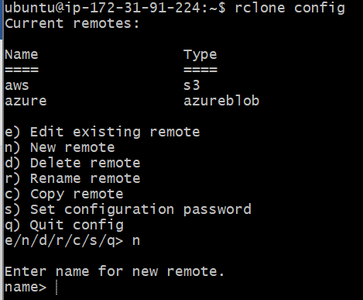  
Select 5 for Amazon S3 storage providers  
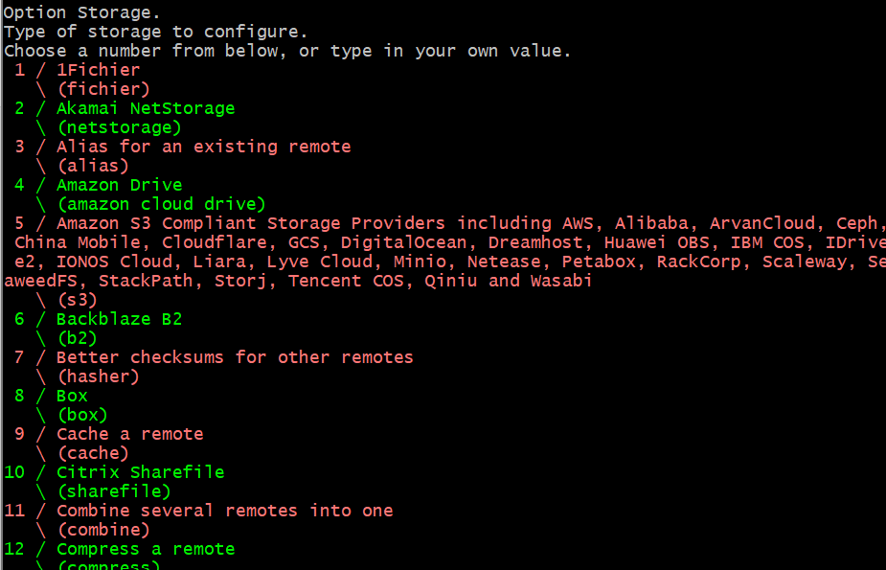  
Select 1 for AWS S3 provider  
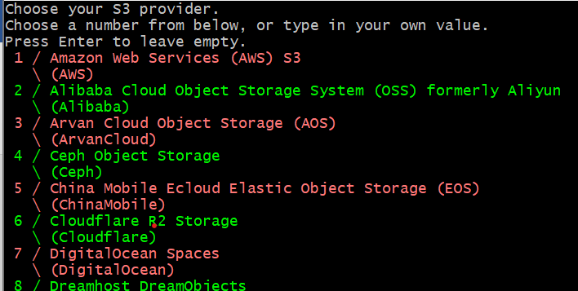  
  
  
Since we already have AWS credentials select 1  
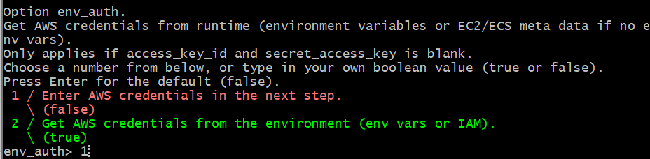  
Enter access_key_id:   
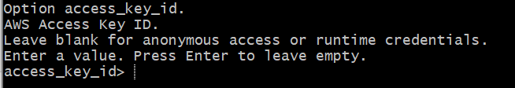  
Enter secret_access_key:  
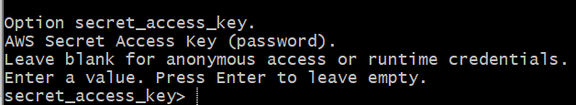  
Select region : select 1 for default  
For Option Endpoint : leave it blank  
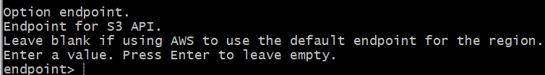  
Location_constraint> press enter for default region(us-east-1)  
Select act> 1  
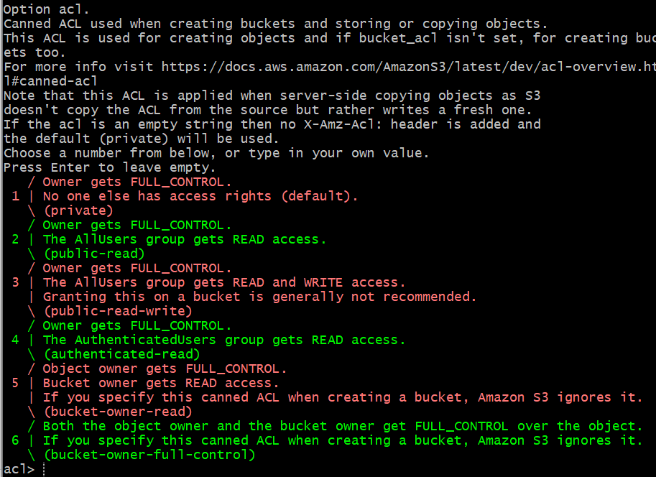  
server_side_encryption> 1 for none  
sse_kms_key_id> 1 for none  
Storage Class> 1 for default  
Edit advance config? n   
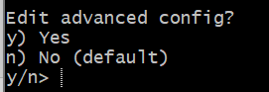  
This completes the configuration  
Choose y to keep this config  
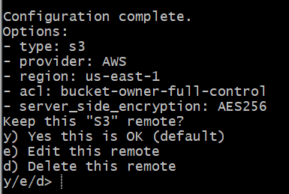

2. Azure Blob configure on rclone

Same as above select n for New Remote  
Enter remote name : Azure  
Storage> 30 for Azure blob  
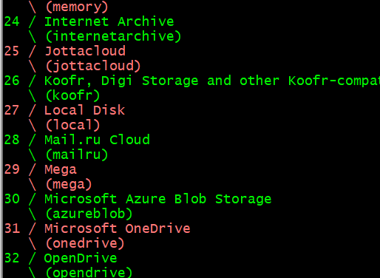  
Enter Azure Storage account Name> testals (Enter existing storage account name)  
env_auth> enter for default false  
Key> Enter Storage account key here NOTE:[for this account key go to storage account, on left hand side select account key]  
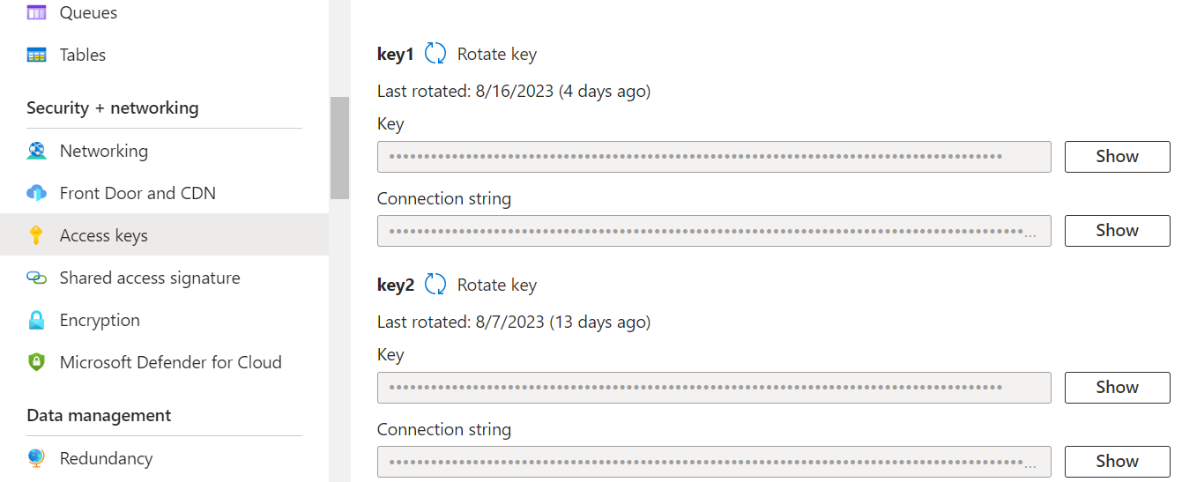  
sas_url> for specific objects enter sas url else, leave this blank  
Option tenant> Press Enter to leave Empty  
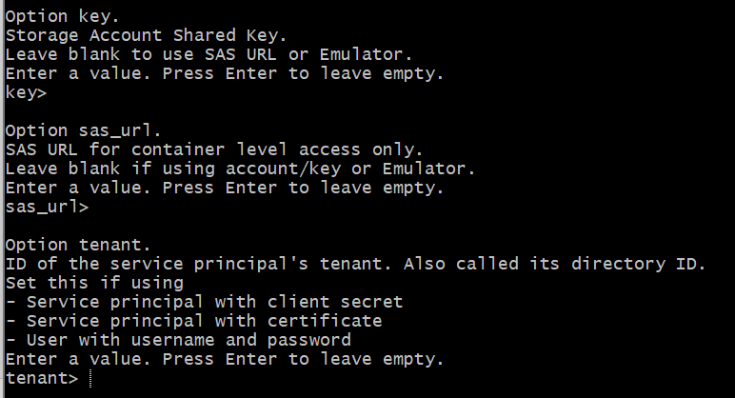  
client_id> Press Enter to leave empty  
client_secret> Press Enter to leave empty  
client_certificate_path> Press Enter to leave empty  
client_certificate_password> n for blank  
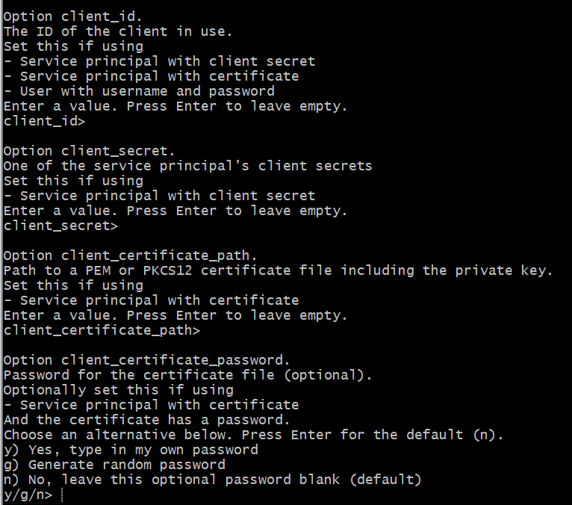  
Edit advanced config? n(default)  
  
  
  
  
  
  
  
  
Keep this blob remote? Y (default)  
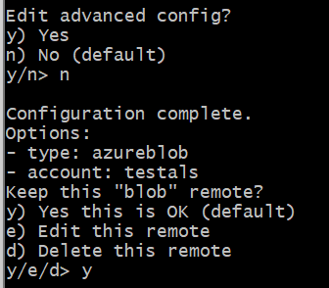

Other commands:  
  
To check list of remotes: rclone listremotes

To copy files from Azure to AWS:   
rclone copy AZStorageAccount:blob-container/path/ s3:examplebucket-01/path/

IAM role Policy for S3 bucket:  
  
{

"Version": "2012-10-17",

"Statement": [

{

"Effect": "Allow",

"Action": [

"s3:ListBucket",

"s3:DeleteObject",

"s3:GetObject",

"s3:PutObject",

"s3:PutObjectAcl"

],

"Resource": [

"arn:aws:s3:::BUCKET_NAME/*",

"arn:aws:s3:::BUCKET_NAME"

]

},

{

"Effect": "Allow",

"Action": "s3:ListAllMyBuckets",

"Resource": "arn:aws:s3:::*"

}

]

}